Experiment Number: 2

MATLAB Simulation of Cellular Coverage, Cell Splitting and Handoff in a Multi-Cell Network

Objective 1: Model adjacent hexagonal cell coverage areas.

MATLAB Program 1 — Model adjacent hexagonal cell coverage areas.

clear;
clc;
close all;
cellRadiusKm = 0.5;
% Axial coordinates for the central cell and its six neighbours
axial = [ ...
0, 0;
1, 0;
1, -1;
0, -1;
-1, 0;
-1, 1;
0, 1];
% Convert axial coordinates to Cartesian cell-centre positions
xCenter = sqrt(3) * cellRadiusKm .* ...
(axial(:,1) + axial(:,2)/2);
yCenter = 1.5 * cellRadiusKm .* axial(:,2);
% Hexagon vertices
angle = deg2rad(30:60:330);
figure;
hold on;
for k = 1:length(xCenter)
xVertex = xCenter(k) + cellRadiusKm * cos(angle);
yVertex = yCenter(k) + cellRadiusKm * sin(angle);
patch(xVertex, yVertex, [0.80 0.90 1.00], ...
'EdgeColor', [0.10 0.25 0.50], ...
'LineWidth', 1.5);
text(xCenter(k), yCenter(k), sprintf('Cell %d', k), ...
'HorizontalAlignment', 'center', ...
'FontWeight', 'bold');
end
axis equal;
grid on;
xlabel('Horizontal distance (km)');
ylabel('Vertical distance (km)');
title(sprintf('Adjacent Hexagonal Cells (Radius = %.2f km)', ...
cellRadiusKm));
hold off;
A diagram of seven adjacent hexagonal cells. Change cellRadiusKm to
view the layout at another scale.

OUTPUT:

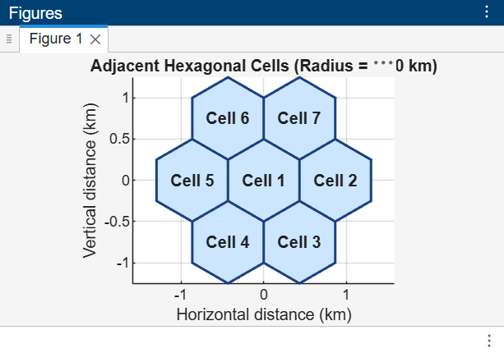

Objective 2: Estimate how cell radius affects the number of cells needed to cover a fixed area.

Program 2 — Estimate cell count for different cell radii
clear;
clc;
close all;
studyAreaKm2 = 4.0;
cellRadiiKm = [1.00, 0.75, 0.50];
% Area of a regular hexagonal cell
cellAreaKm2 = (3 * sqrt(3) / 2) .* cellRadiiKm.^2;
% Approximate cell count, rounded up to cover the study area
estimatedCells = ceil(studyAreaKm2 ./ cellAreaKm2);
results = table(cellRadiiKm', cellAreaKm2', estimatedCells', ...
'VariableNames', {'CellRadius_km', 'CellArea_km2', ...
'EstimatedNumberOfCells'});
disp('Estimated cells required:');
disp(results);
figure;
bar(cellRadiiKm, estimatedCells, 0.6);
xlabel('Cell radius (km)');
ylabel('Estimated number of cells');
title('Cell Radius versus Estimated Number of Cells');
grid on;

OUTPUT:
Estimated cells required:
CellRadius_km CellArea_km2 EstimatedNumberOfCells
_____________ ____________ ______________________
1 2.5981 2
0.75 1.4614 3
0.5 0.64952 7

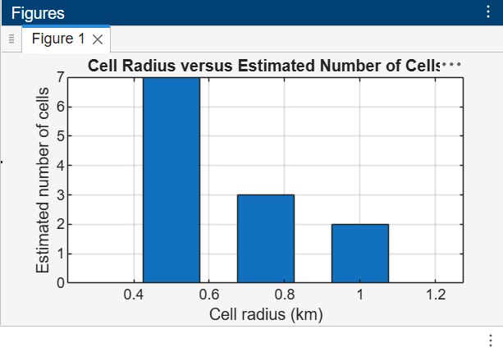

Objective: Compare estimated user capacity for different cell sizes under stated assumptions.

Program 3 — Compare user capacity for different cell sizes
clear;
clc;
close all;
studyAreaKm2 = 4.0;
userDensityPerKm2 = 30;
maxUsersPerCell = 50;
cellRadiiKm = [1.00, 0.75, 0.50];
totalDemand = studyAreaKm2 * userDensityPerKm2;
% Hexagonal cell area and approximate cell count
cellAreaKm2 = (3 * sqrt(3) / 2) .* cellRadiiKm.^2;
estimatedCells = ceil(studyAreaKm2 ./ cellAreaKm2);
% Estimate network capacity and users served
networkCapacity = estimatedCells .* maxUsersPerCell;
usersServed = min(totalDemand, networkCapacity);
results = table(cellRadiiKm', estimatedCells', networkCapacity', ...
usersServed', ...
'VariableNames', {'CellRadius_km', 'EstimatedNumberOfCells', ...
'EstimatedNetworkCapacity', 'EstimatedUsersServed'});
disp('Estimated user capacity:');
disp(results);
figure;
bar(cellRadiiKm, [networkCapacity' usersServed'], 'grouped');
hold on;
yline(totalDemand, '--r', 'Total user demand');
xlabel('Cell radius (km)');
ylabel('Number of users');
title('Cell Size and Estimated User Capacity');
legend('Network capacity', 'Users served', 'Total demand', ...
'Location', 'northwest');
grid on;
hold off;
A table and grouped bar chart comparing estimated network capacity with estimated users served. The model assumes 30 users/km² and a maximum of 50 users per cell.

OUTPUT:
Estimated user capacity:
CellRadius_km EstimatedNumberOfCells EstimatedNetworkCapacity EstimatedUsersServed
_____________ ______________________ ________________________ ____________________
1 2 100 100
0.75 3 150 120
0.5 7 350 120

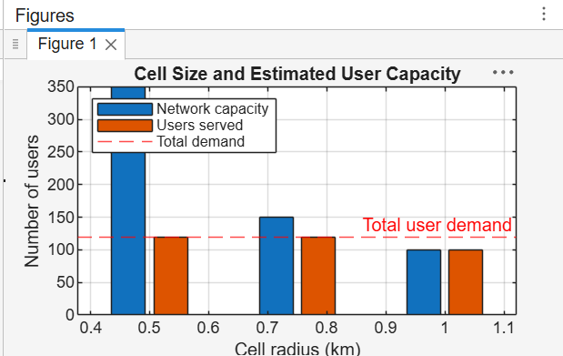

Objective: Simulate a mobile user moving between two cells and identify the handoff point using
received signal strength.

Program 4 — Simulate movement and identify the handoff point

clear;
clc;
close all;

%% Cell and Base Station Parameters

cellRadiusKm = 0.5;
radiusM = cellRadiusKm * 1000;

% Centre-to-centre spacing of horizontally adjacent hexagonal cells
separationM = sqrt(3) * radiusM;

% Mobile user moves from base station 1 toward base station 2
xMeters = linspace(0, separationM, 201);

%% Distance from Mobile User to Each Base Station

minimumDistanceM = 20;
% Prevent log10(0) at a base-station location

distance1M = max(abs(xMeters), minimumDistanceM);
distance2M = max(abs(xMeters - separationM), minimumDistanceM);

%% Path-Loss Parameters

transmitPowerdBm = 30;
pathLossAt1m_dB = 40;
pathLossExponent = 3.5;

%% Received Power Calculation

receivedPower1dBm = transmitPowerdBm - pathLossAt1m_dB ...
- 10 * pathLossExponent * log10(distance1M);

receivedPower2dBm = transmitPowerdBm - pathLossAt1m_dB ...
- 10 * pathLossExponent * log10(distance2M);

%% Handoff Calculation

% Handoff occurs when base station 2 becomes stronger
handoffIndex = find(receivedPower2dBm >= receivedPower1dBm, ...
1, 'first');

handoffPositionM = xMeters(handoffIndex);

fprintf('Estimated handoff position: %.1f m from base station 1\n', ...
handoffPositionM);

%% Received Power Plot

figure;

plot(xMeters / 1000, receivedPower1dBm, ...
'b', 'LineWidth', 1.5);

hold on;

plot(xMeters / 1000, receivedPower2dBm, ...
'r', 'LineWidth', 1.5);

xline(handoffPositionM / 1000, ...
'--k', 'Estimated handoff');

xlabel('Mobile-user position (km)');
ylabel('Estimated received power (dBm)');

title('Received Signal Strength Between Adjacent Cells');

legend('Base station 1', 'Base station 2', ...
'Location', 'best');

grid on;
hold off;

%% Explanation

% A received-power plot for both base stations and a printed
% handoff position is generated.
%
% With the symmetric path-loss assumptions, the handoff occurs
% close to the midpoint between the two base stations.

OUTPUT:



